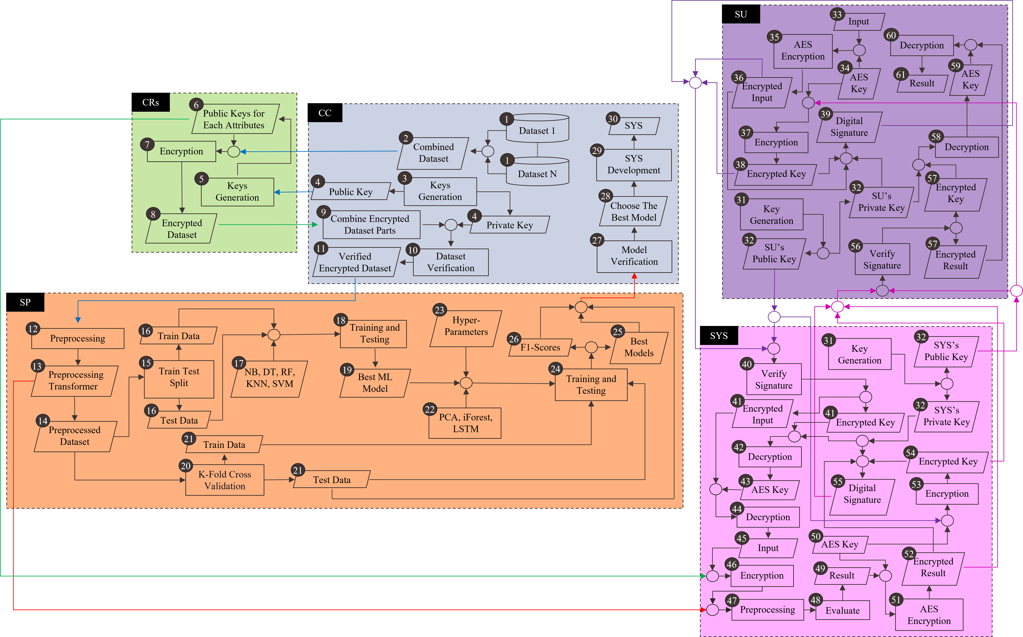

Fig. 1 Proposed Heart Disease Prediction System

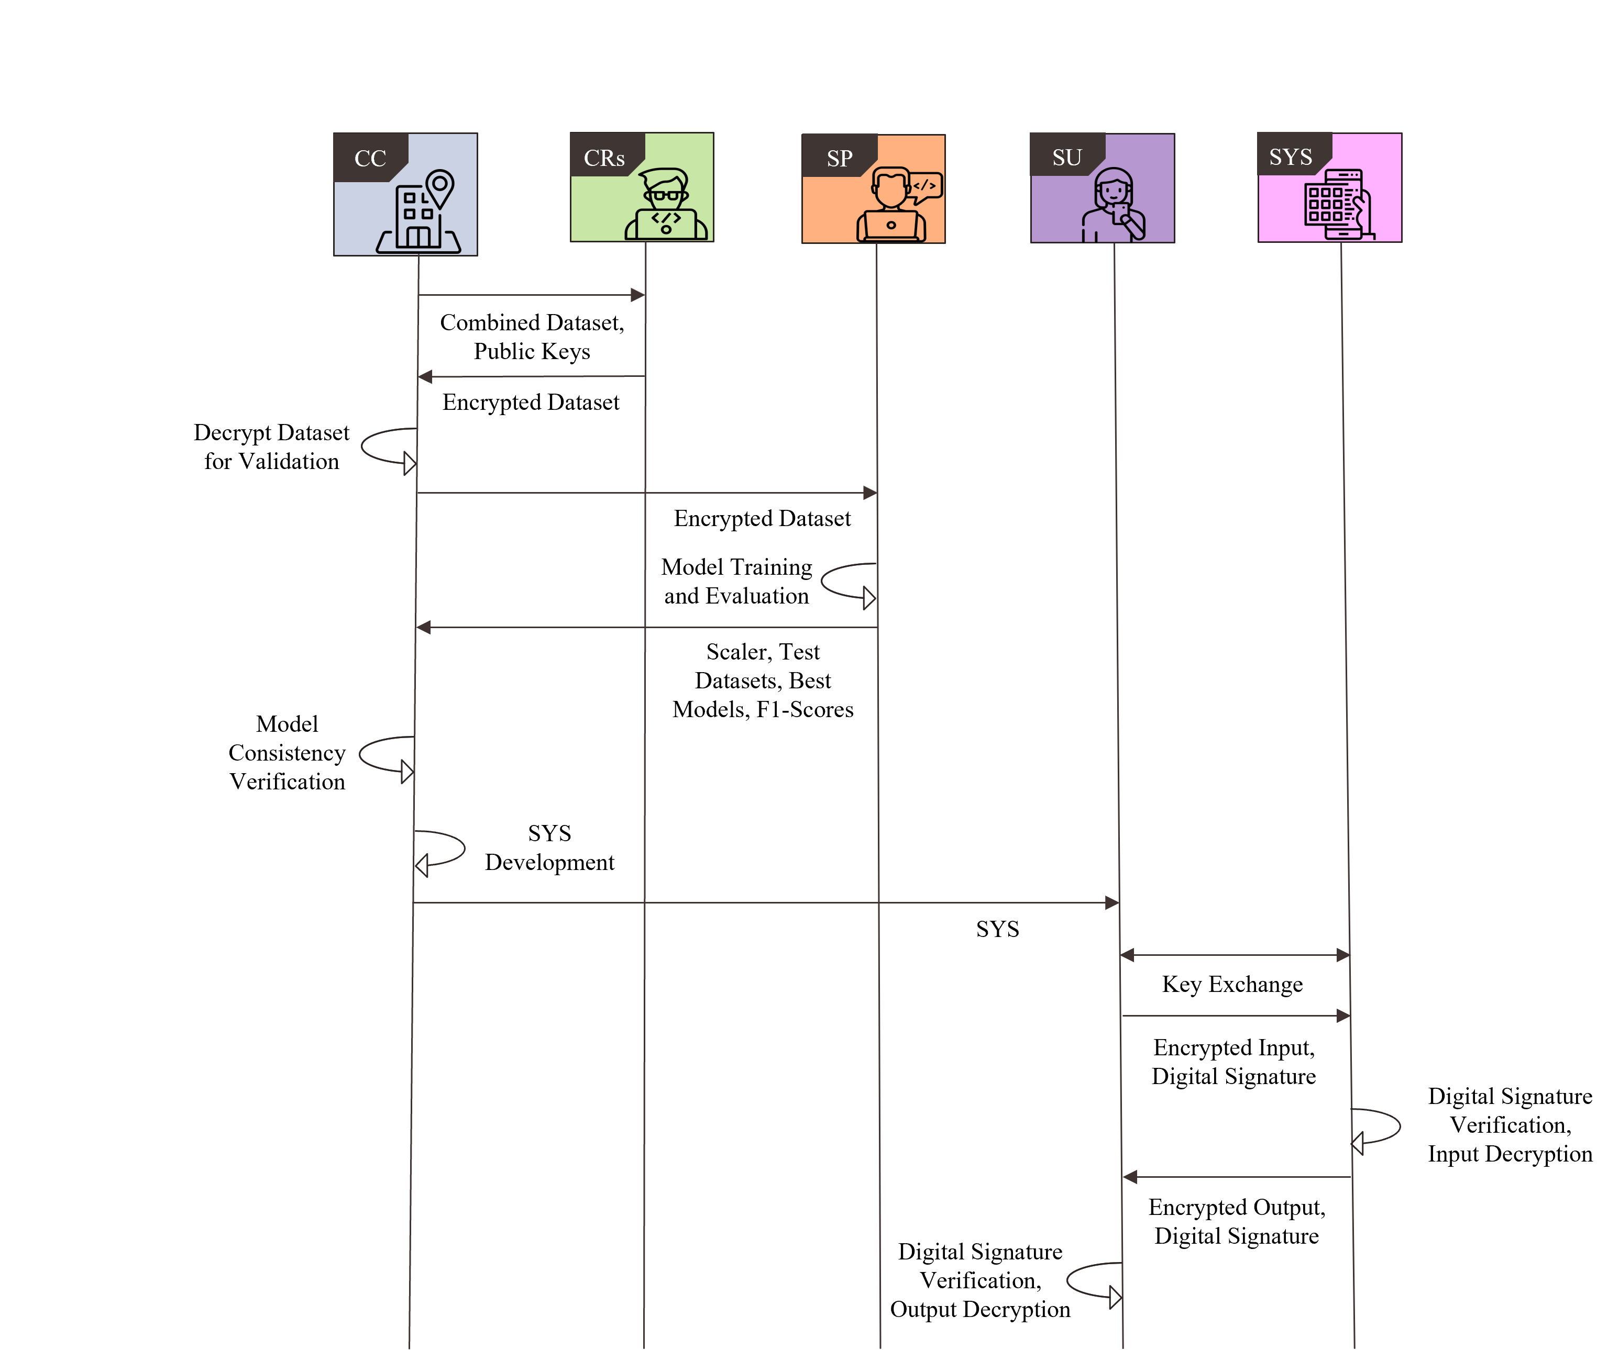

Fig. 2 Interactions among entities